Ubuntu Installation

Step1: Click on New Button and Select name of Virtual Operating System i.e., Ubuntu.

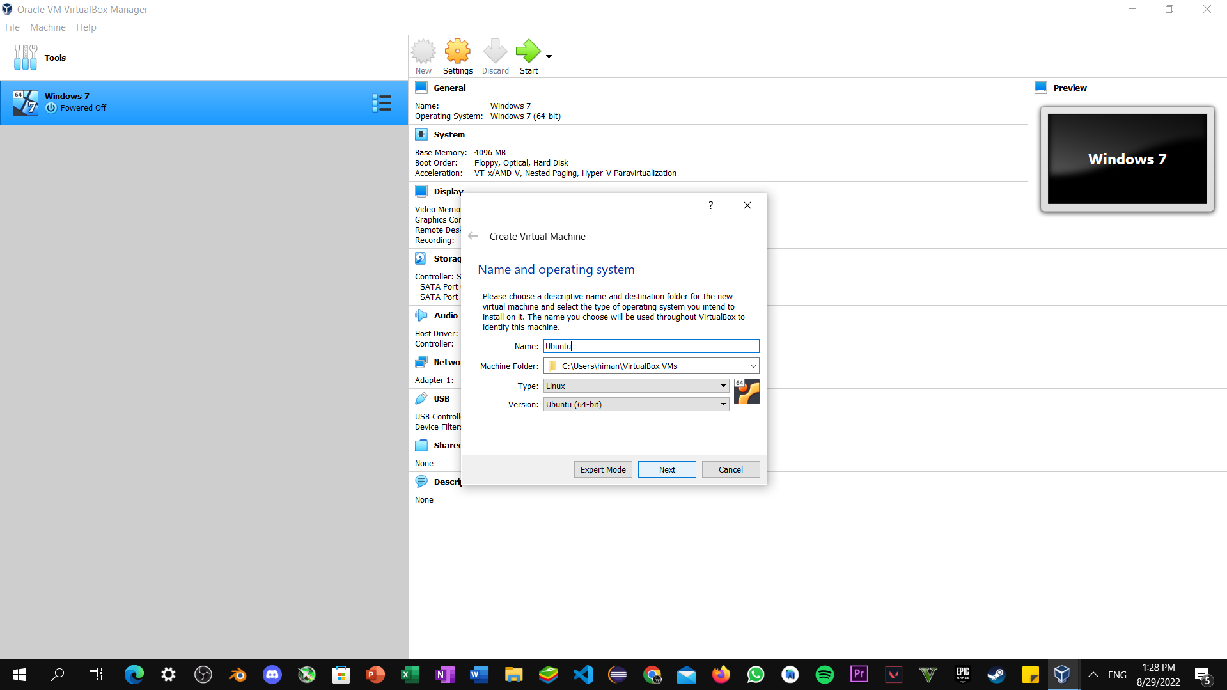

Step2: Now Select Memory Size depend upon the Usability.

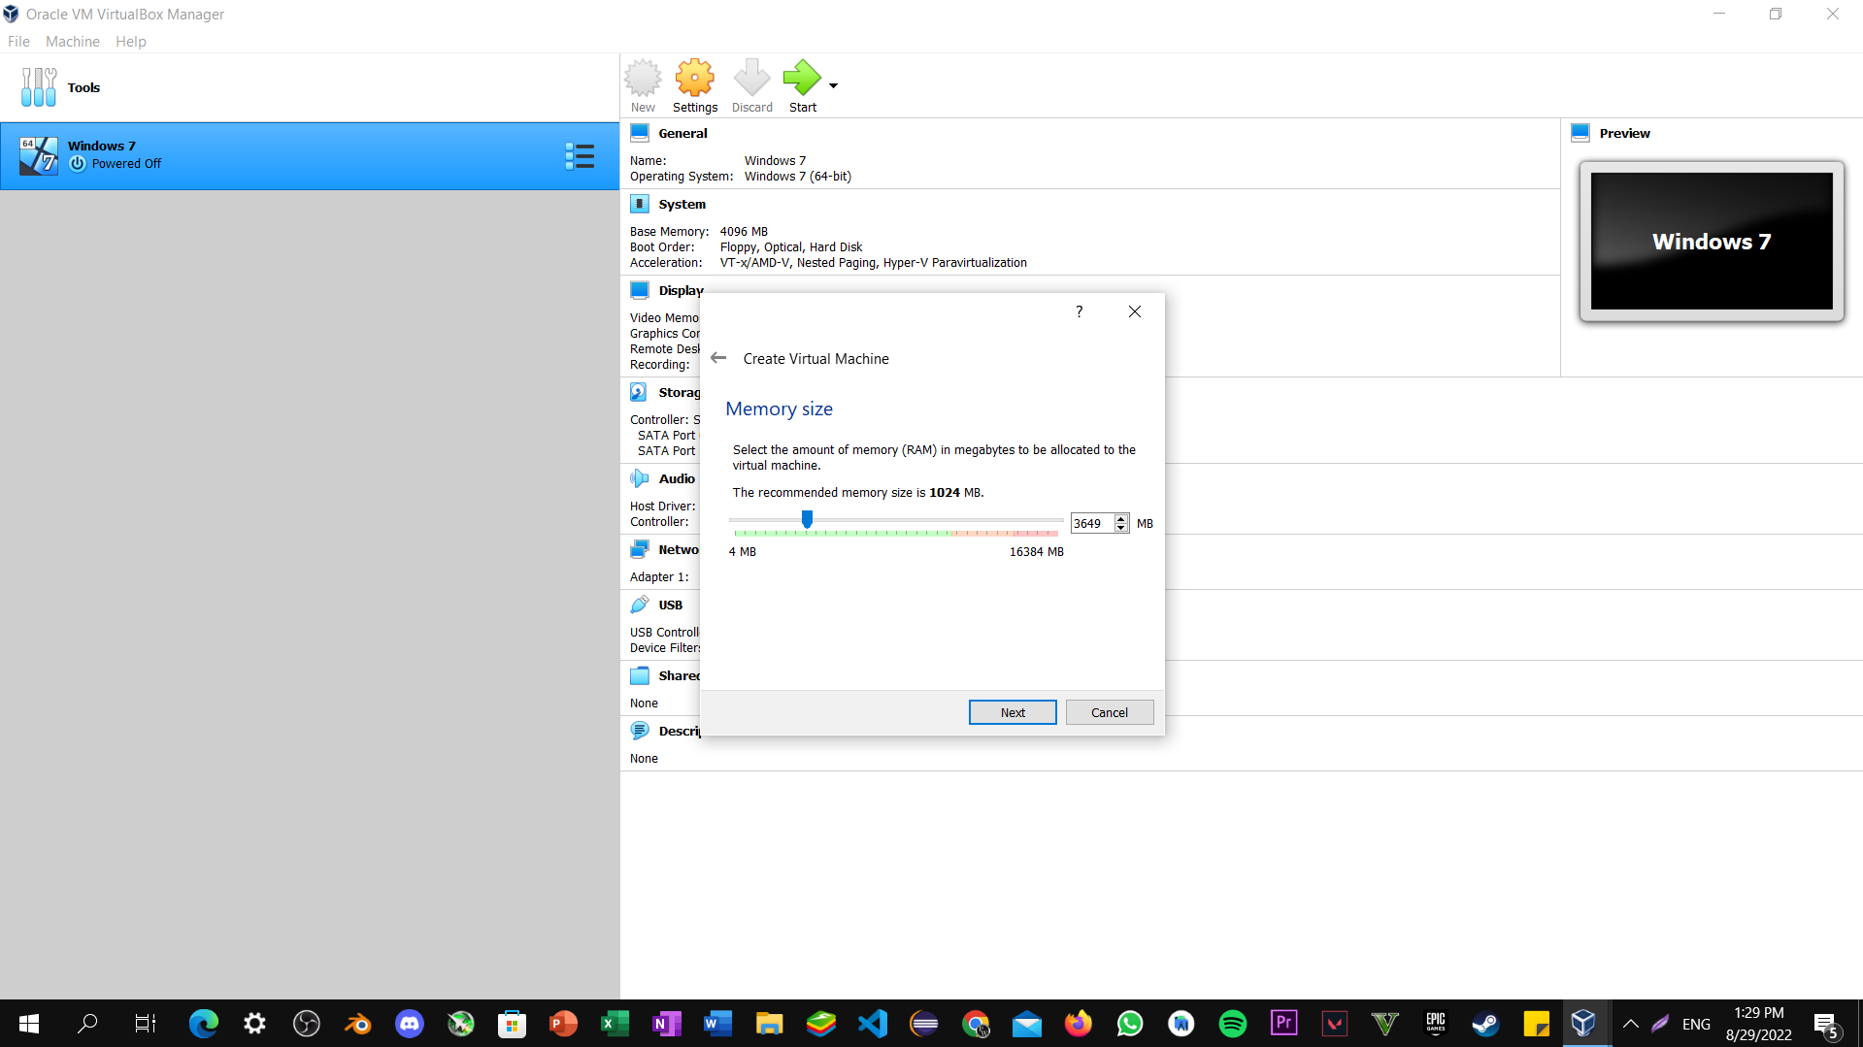

Step3: Select create a Virtual Hard Disk and click next.

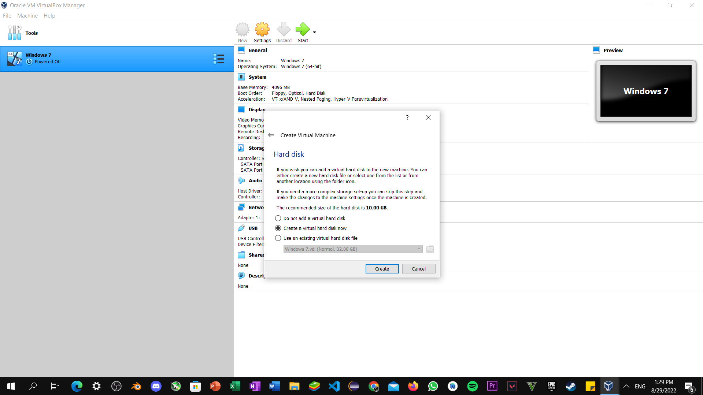

Step4: Don’t make any changes to Default settings and click next.

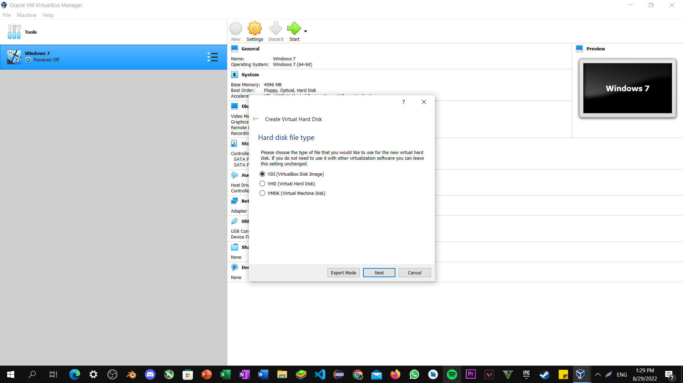

Step5: Select Dynamically allocated and then next.

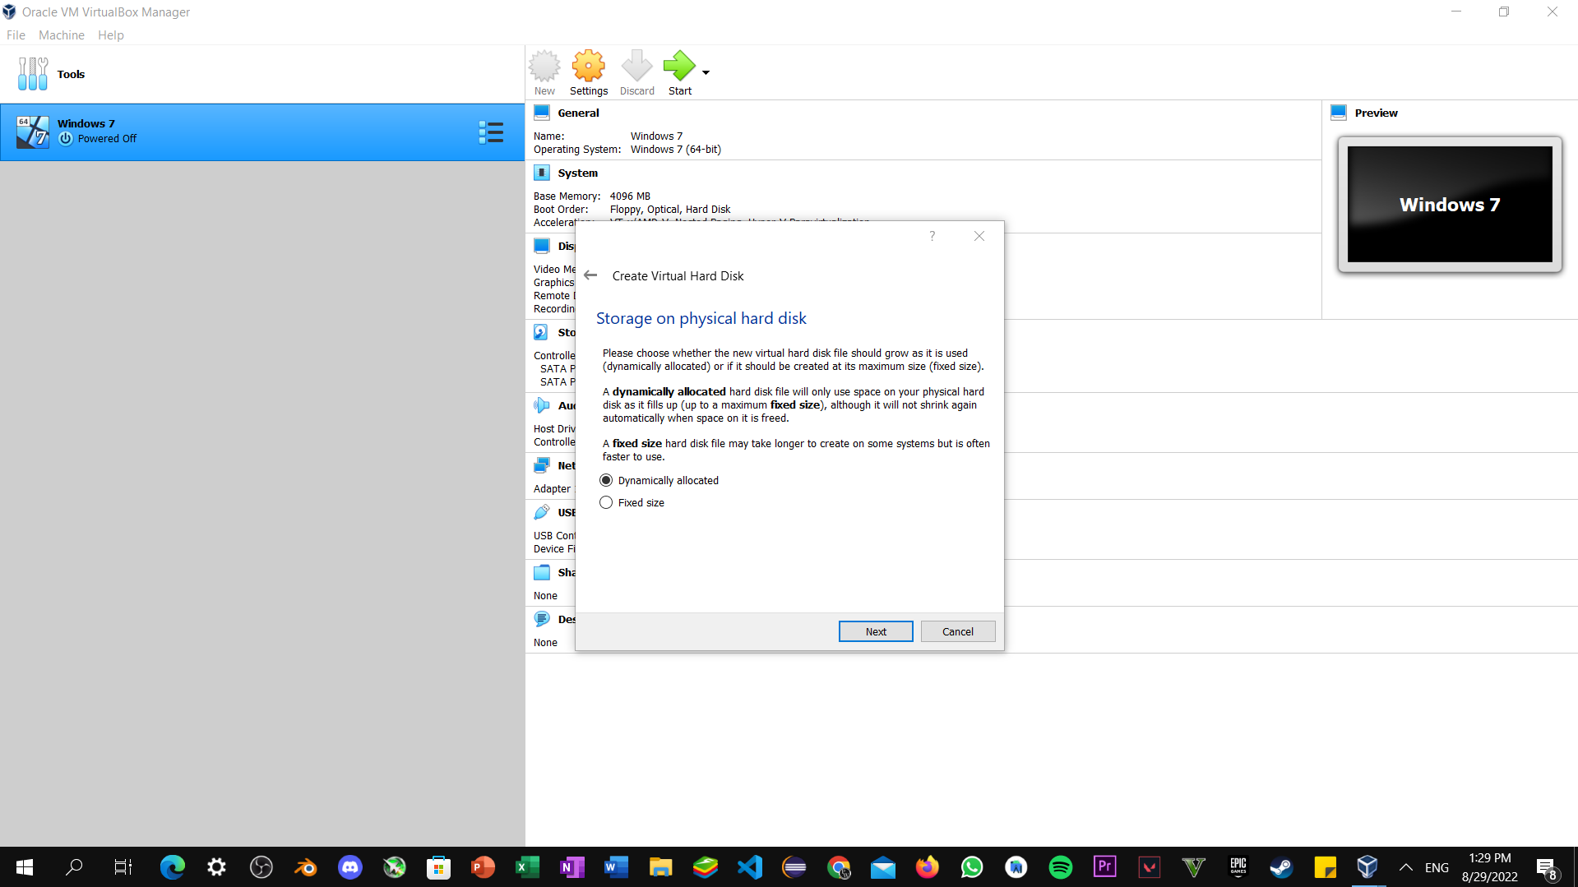

Step6: Now go to settings -> storage under that storage part select Ubuntu ISO Disk image file that downloaded earlier.

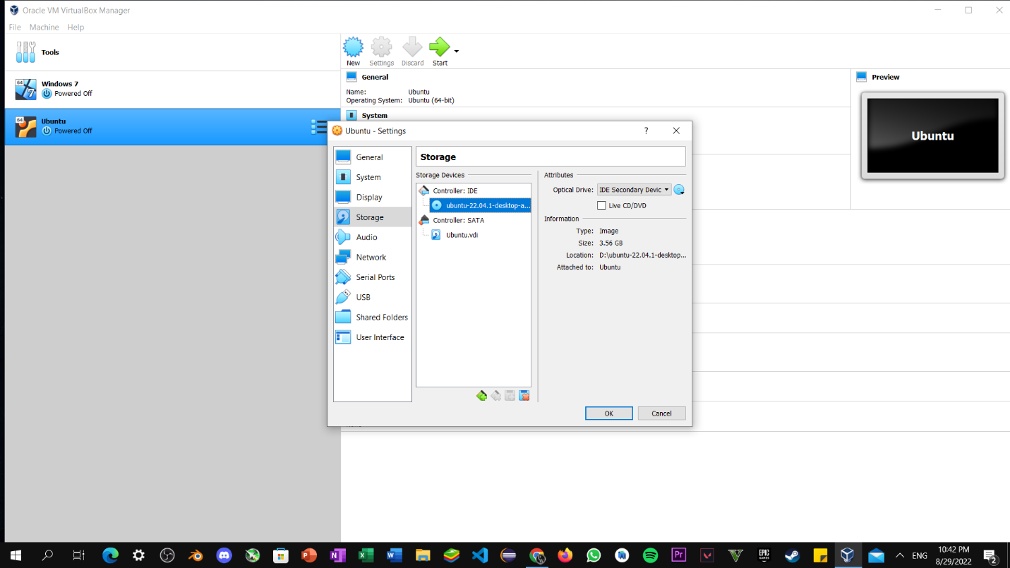

Step7: Now start the installation of virtual machine by clicking install ubuntu.

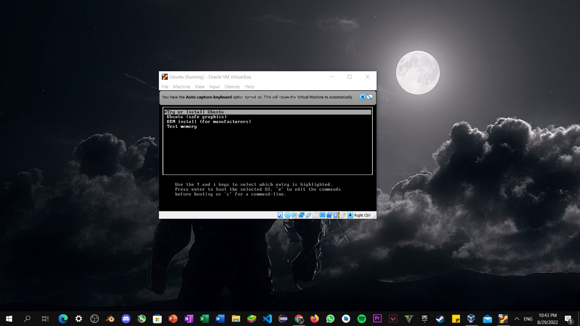

Step8: Now select English language and Click on Install Ubuntu.

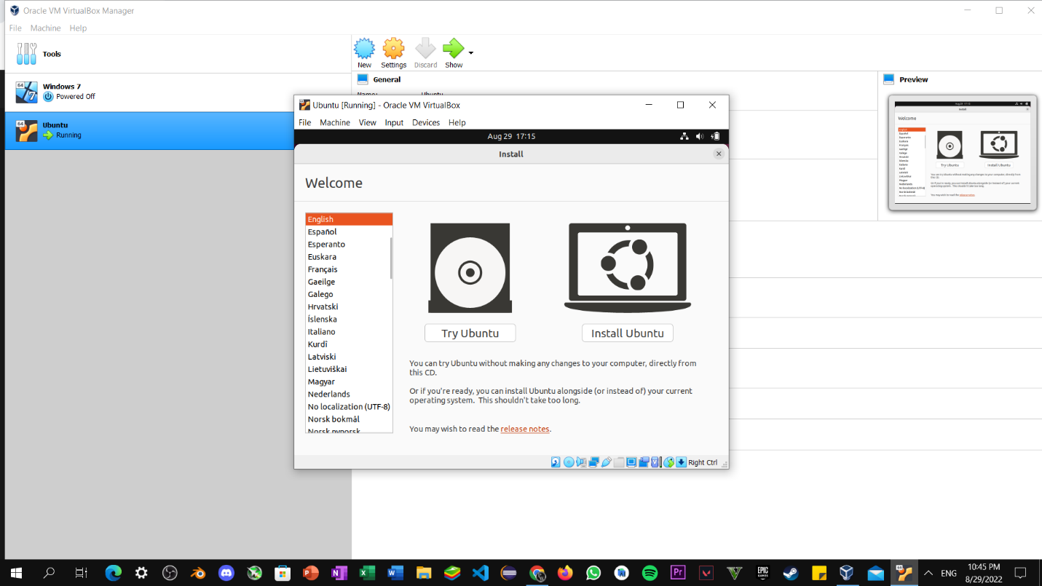

Step9: Now select keyboard layout i.e., English (US).

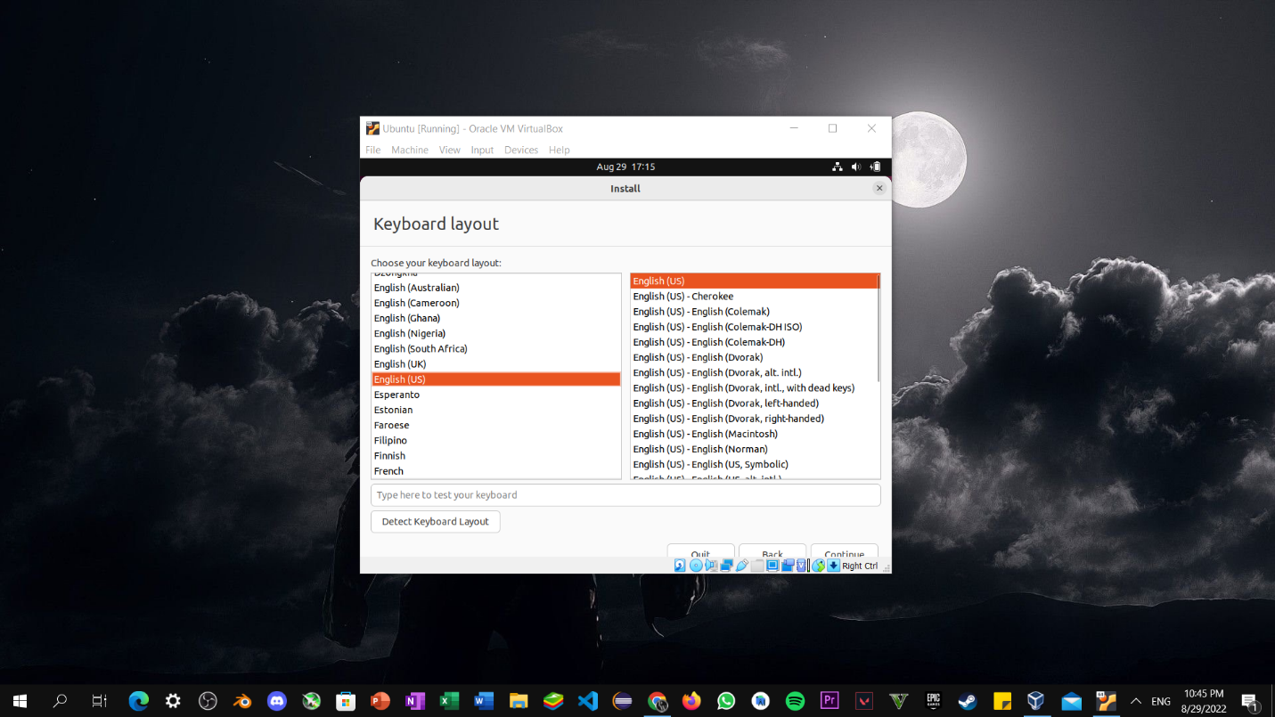

Step10: Check normal installation, download updates while installing ubuntu, install third party software for graphics and then click on next.

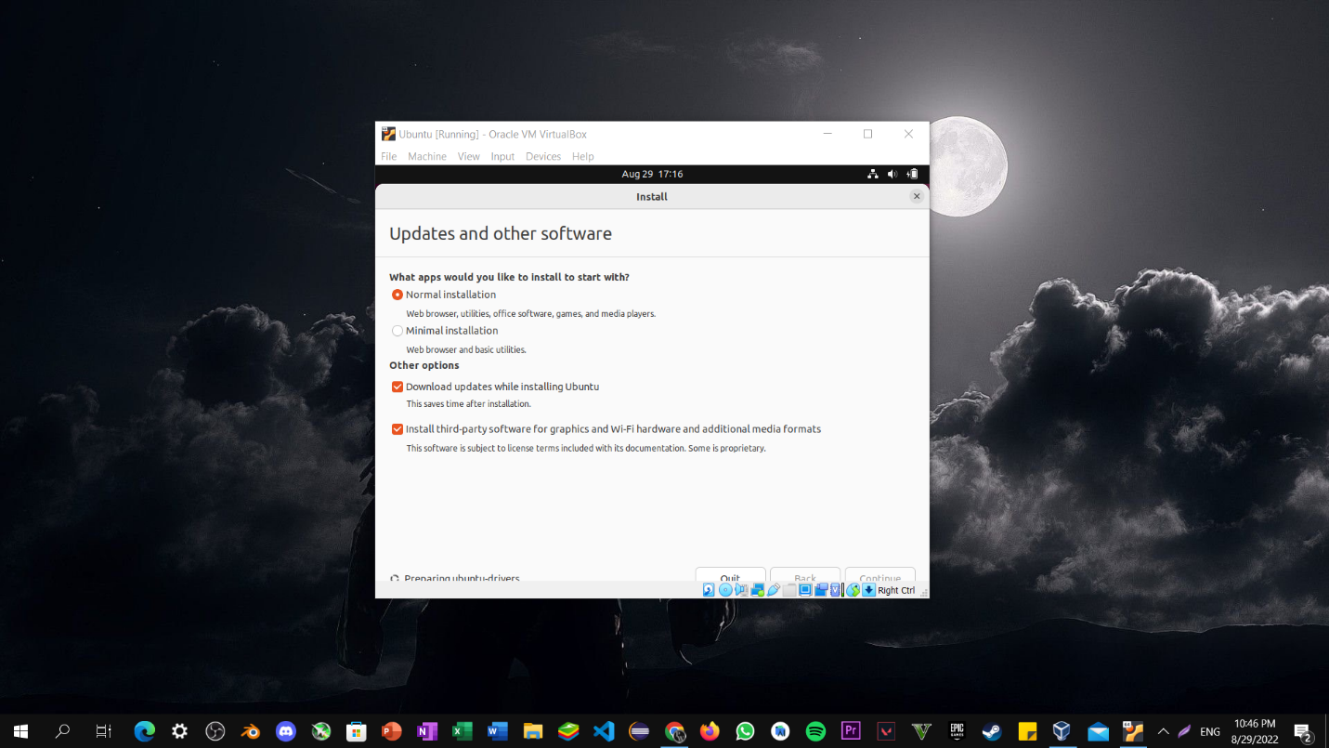

Step11: Check Erase Disk and install ubuntu, this Erase Disk option doesn’t affect current operating system it only make changes to Virtual Disk. Now Check Install Now option.

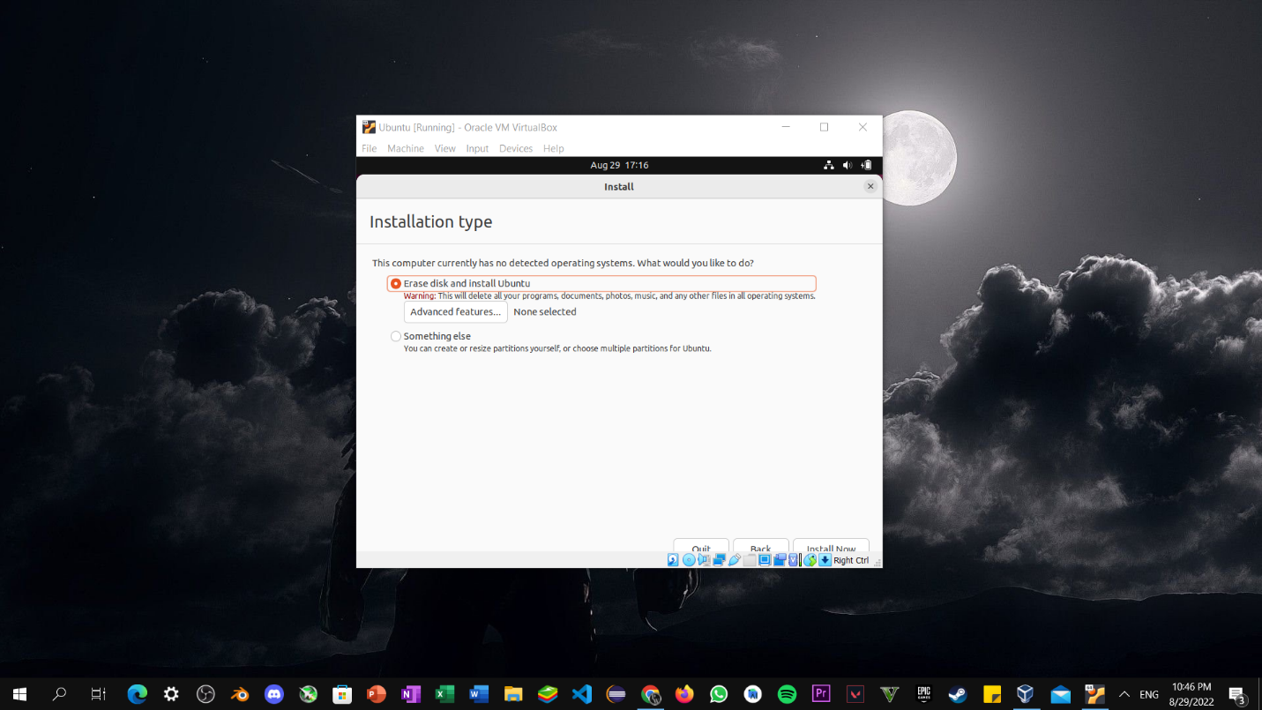

Step12: Now setup virtual machine username and password.

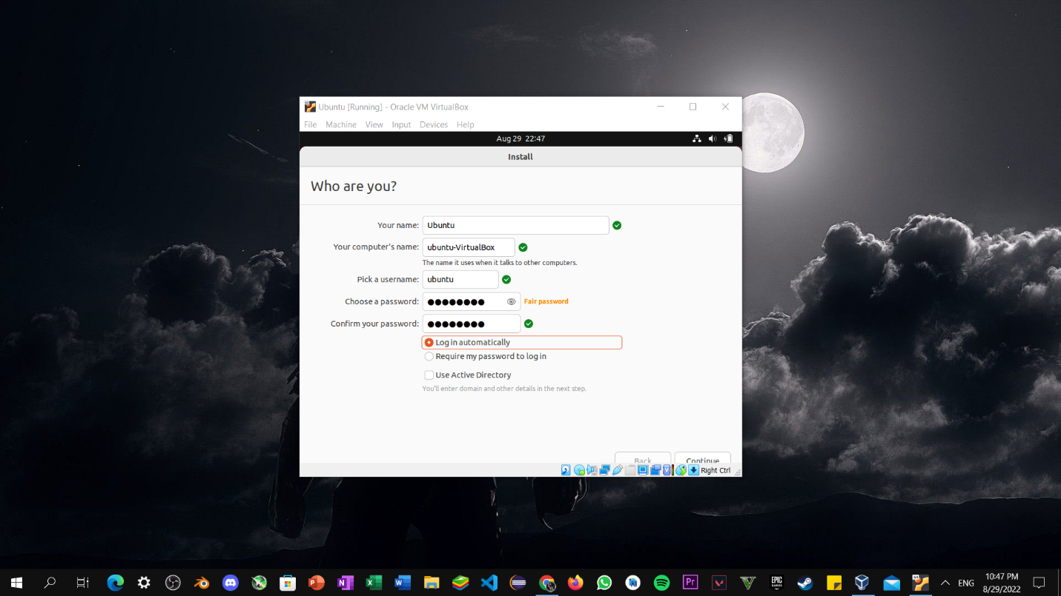

Step13: Now wait for few minutes until installation get completed.

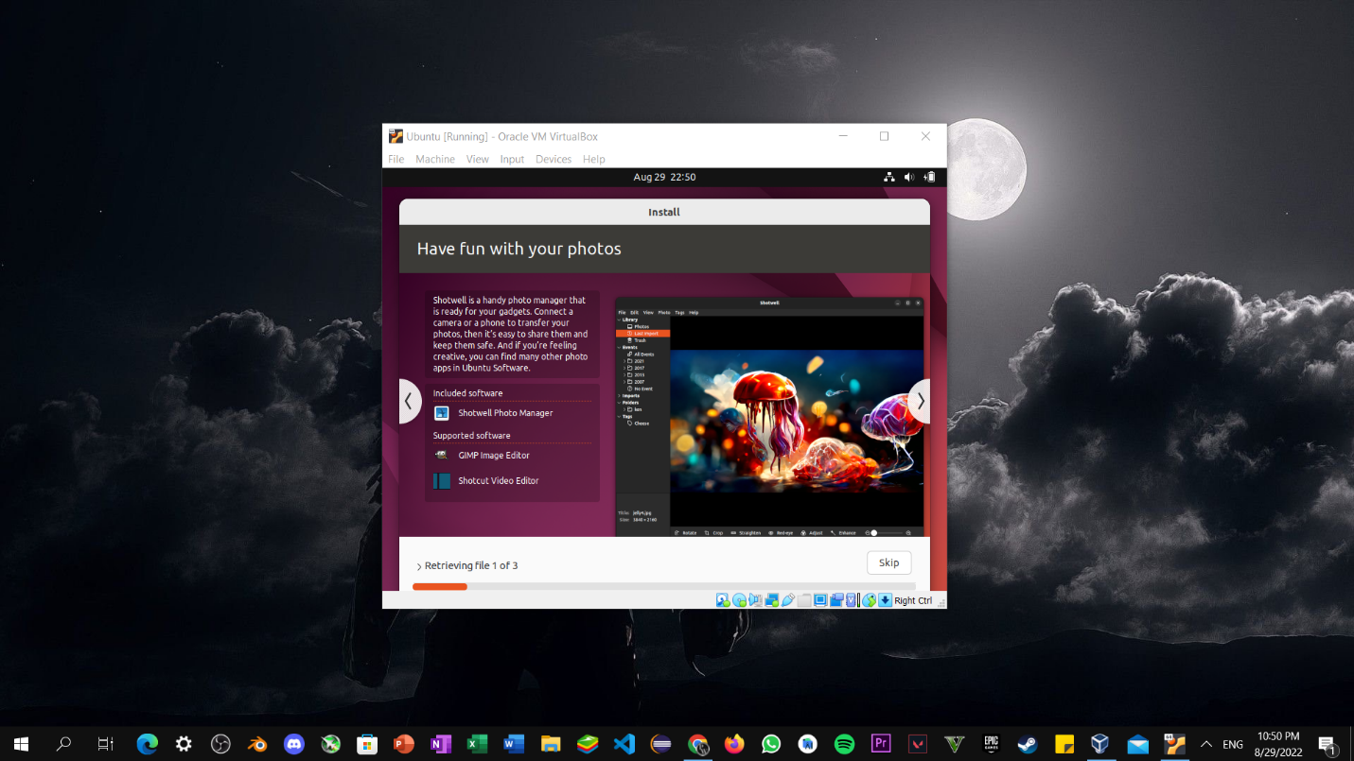

Step14: Once the installation is completed. We need to restart Virtual machine in order to use.

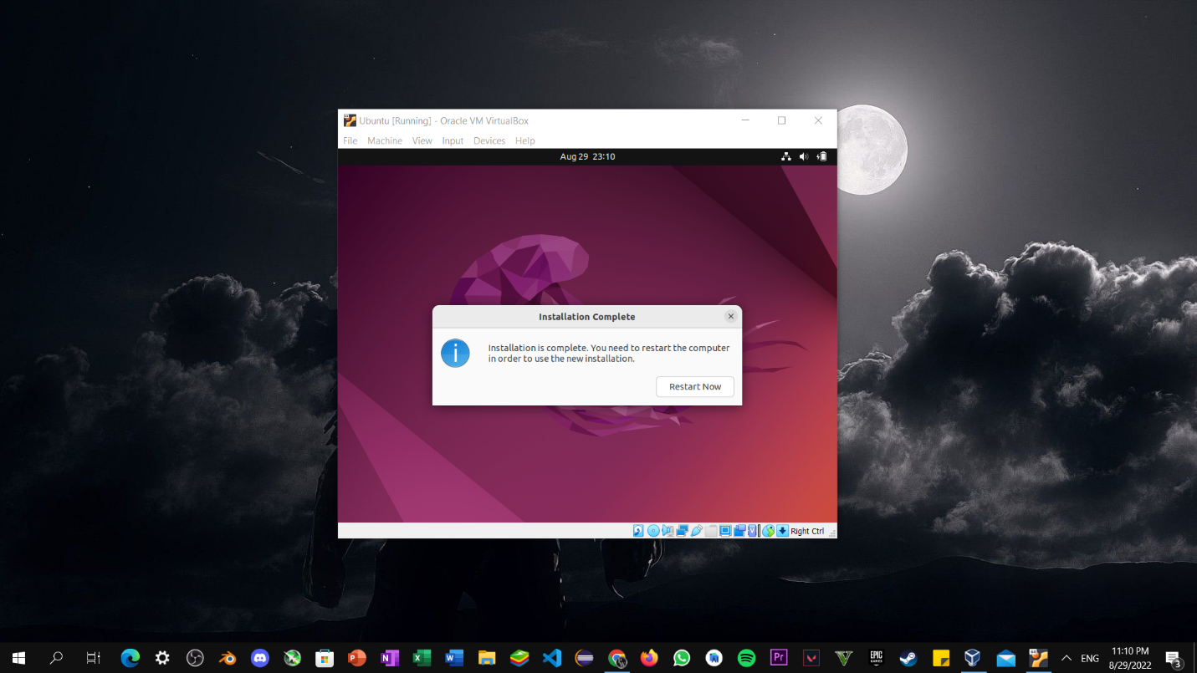

Step15: Now, Enter your password and login to your workspace.

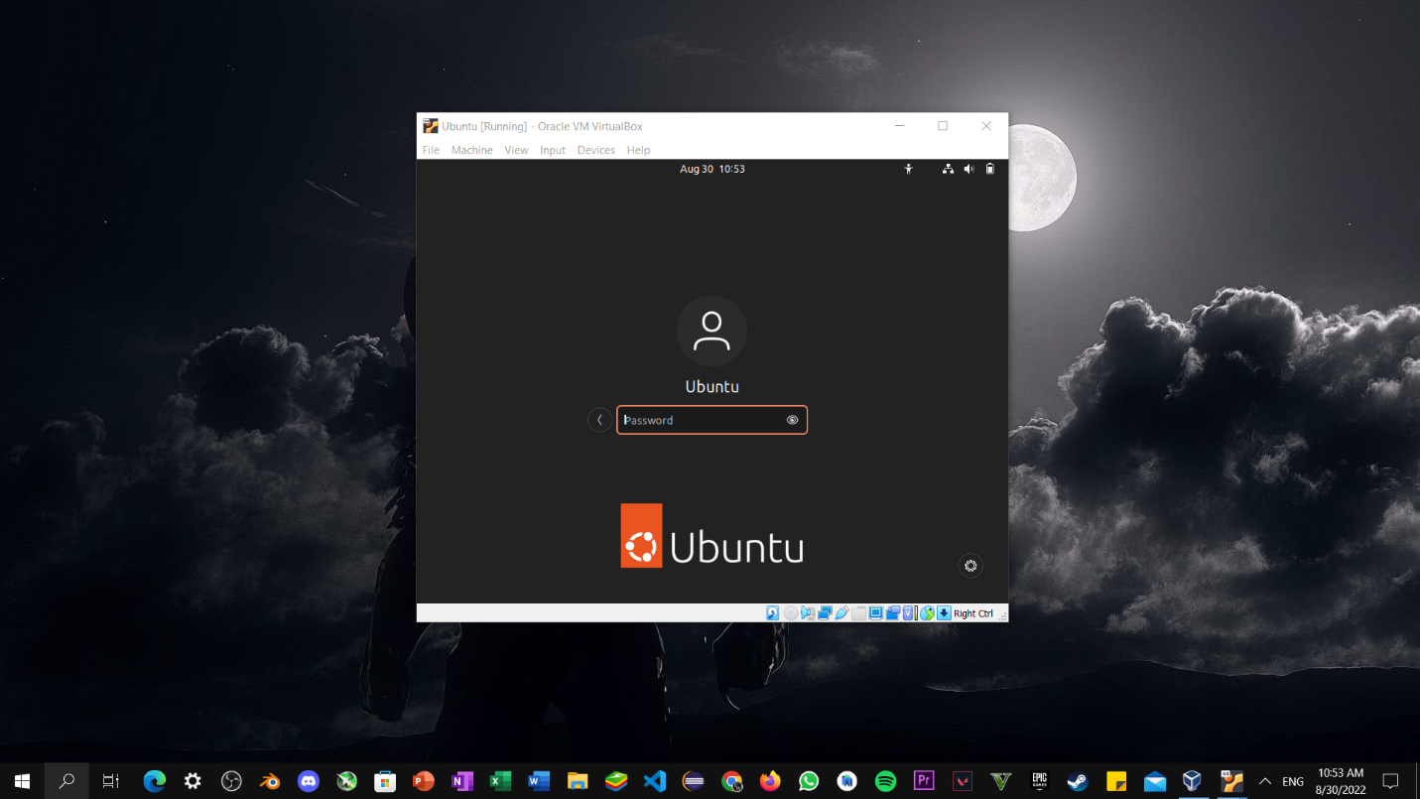

Step13: Ubuntu Workspace.

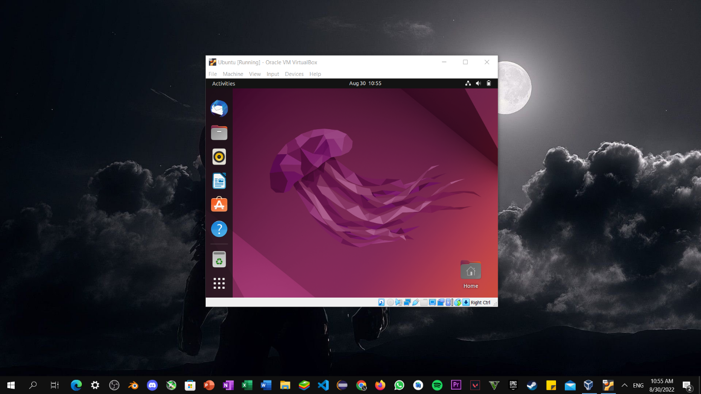

Windows7 Installation

Step1: Click on New Button and Select name of Virtual Operating System i.e., Ubuntu.

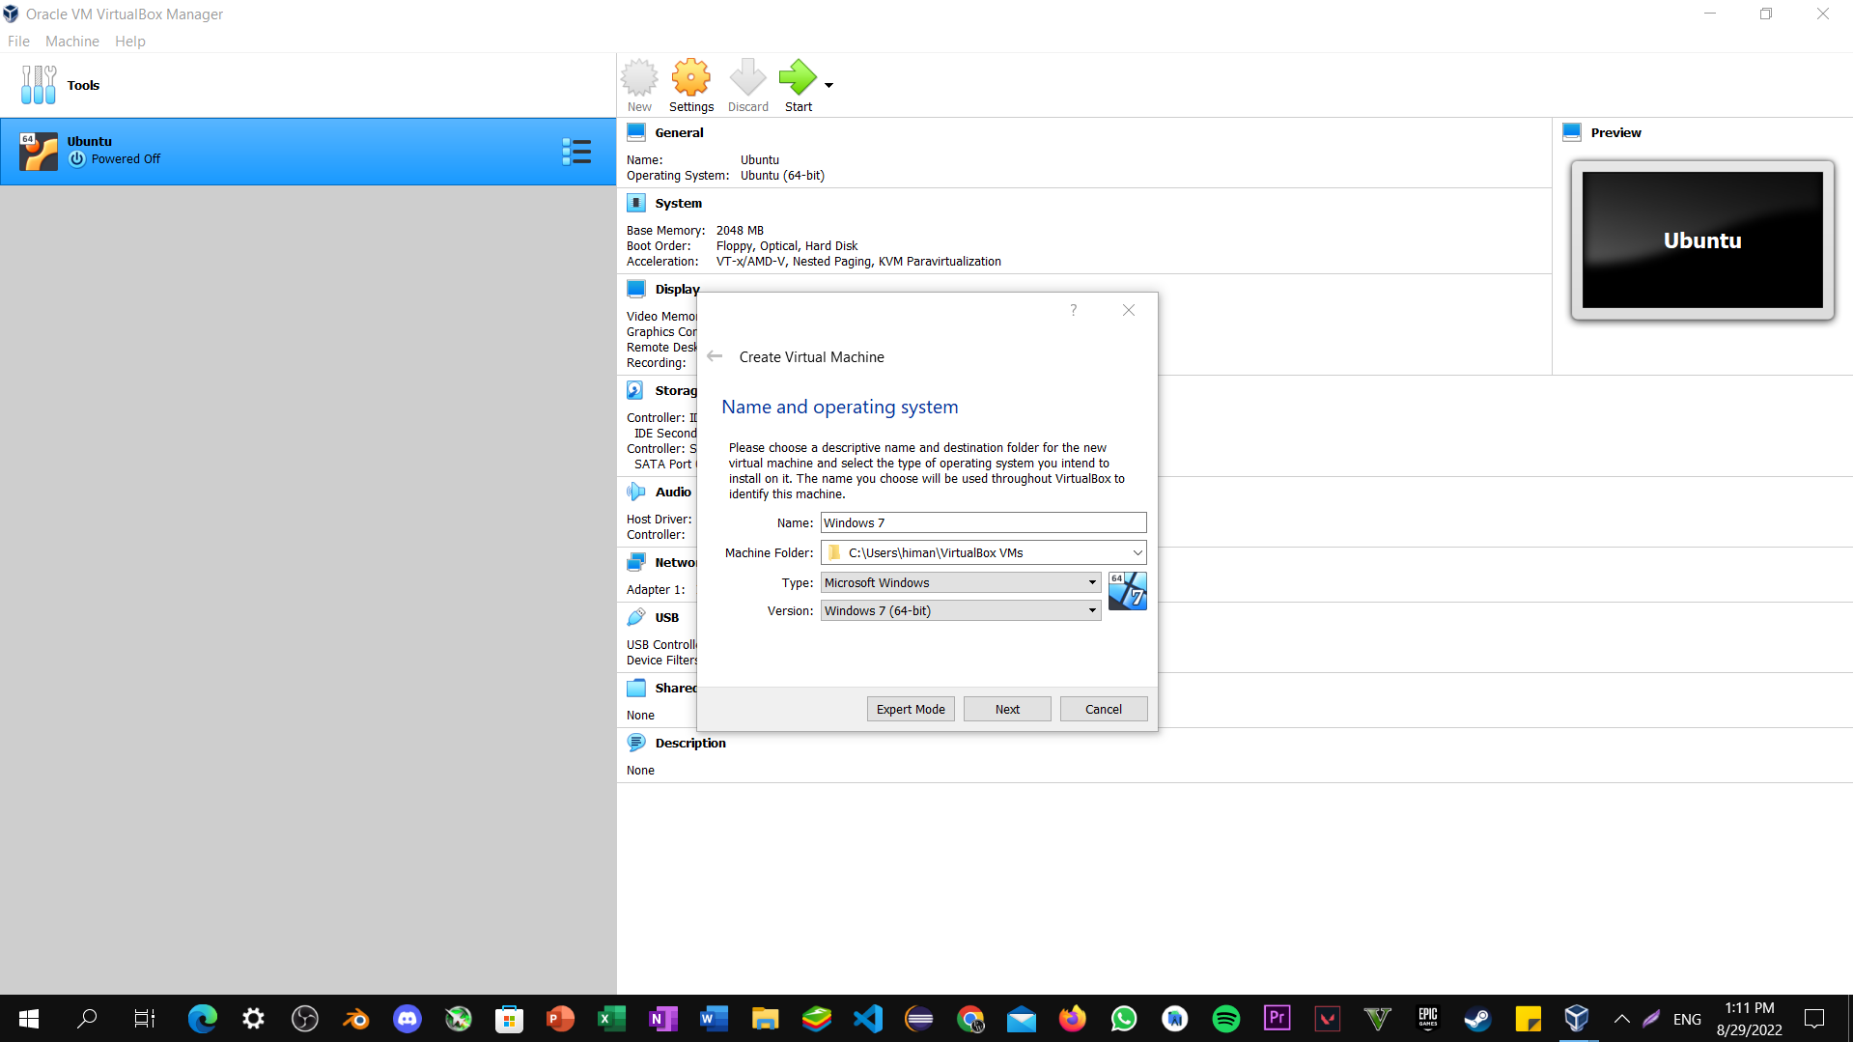

Step2: Now Select Memory Size depend upon the Usability.

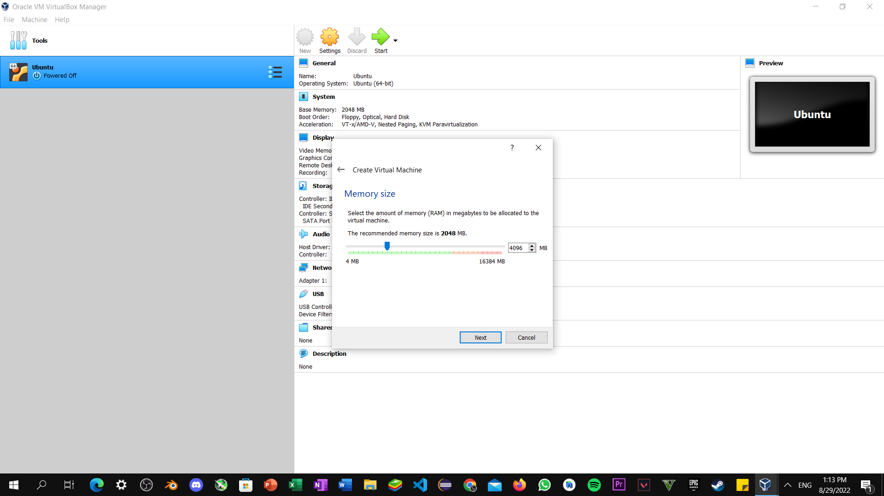

Step3: Select create a Virtual Hard Disk and click next.

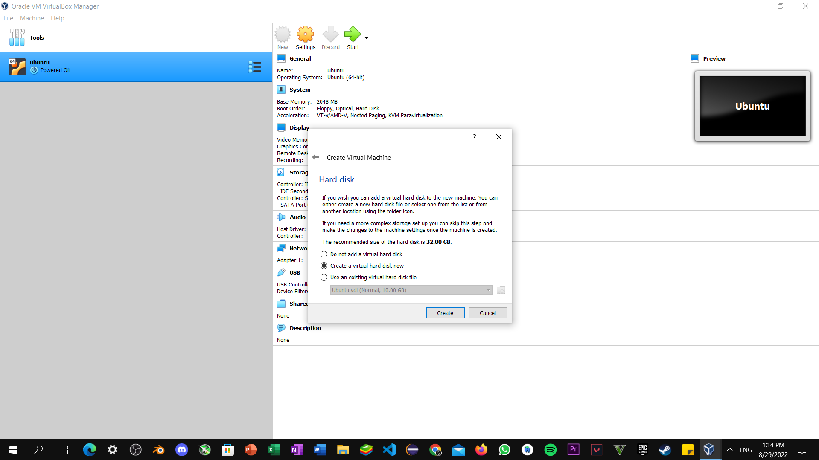

Step4: Don’t make any changes to Default settings and click next.

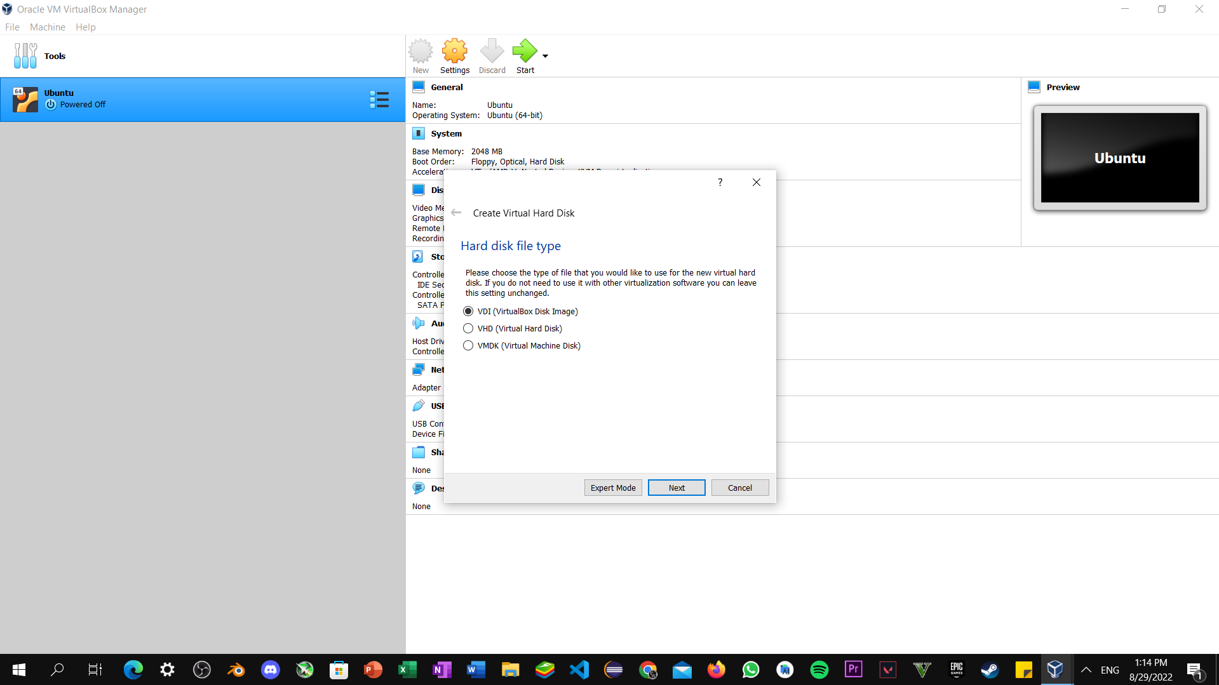

Step5: Select Dynamically allocated and then next.

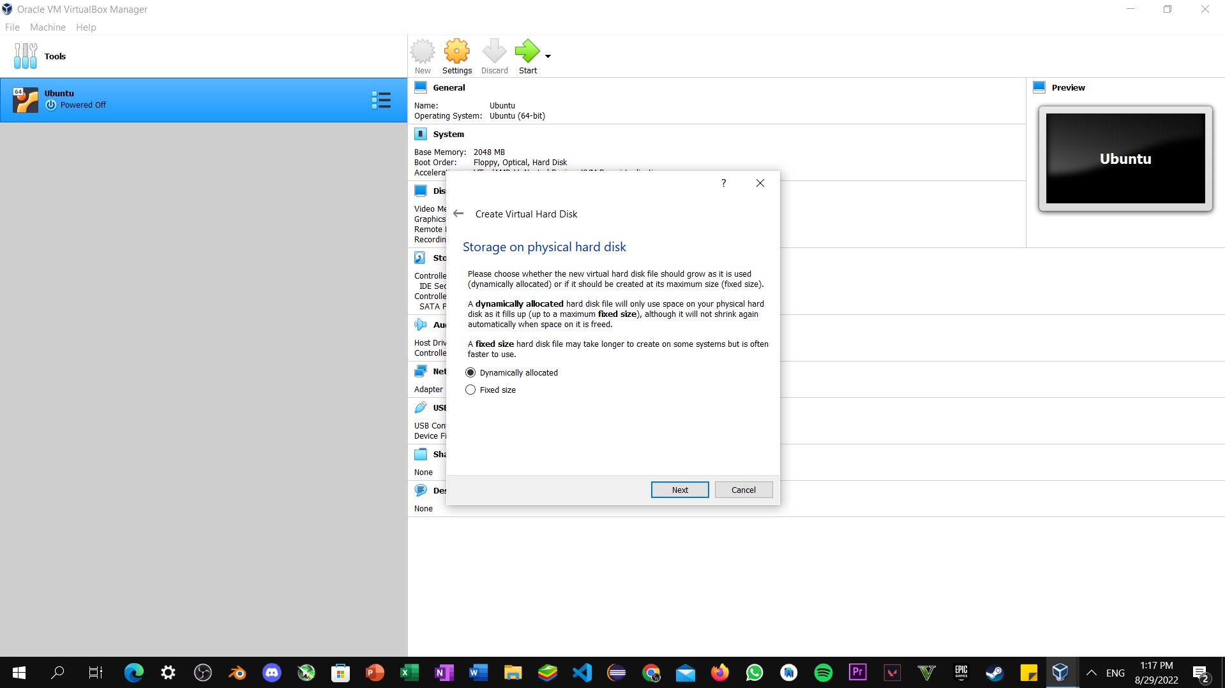

Step6: Now go to settings -> storage under that storage part select Ubuntu ISO Disk image file that downloaded earlier.



Step7: Select the English language and click on next button.

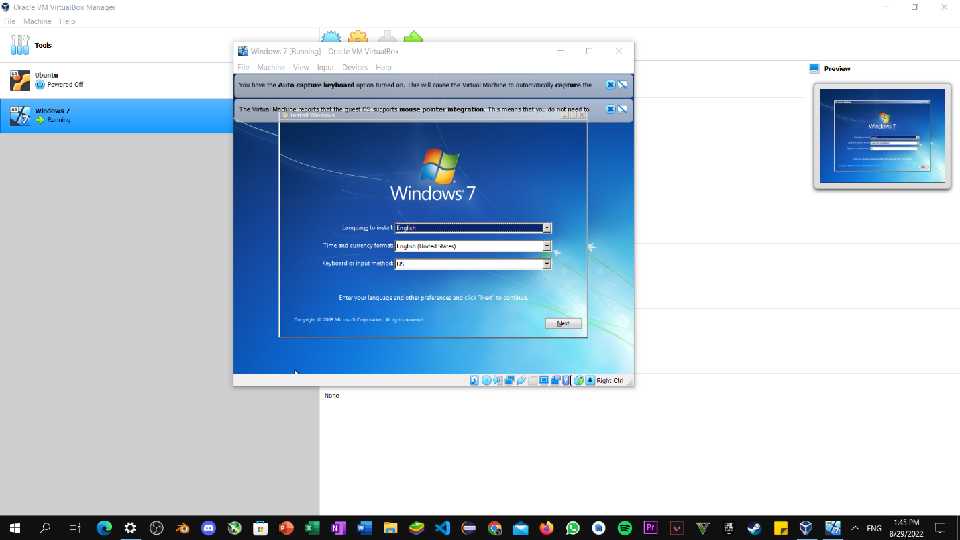

Step8: Now click on install now option.

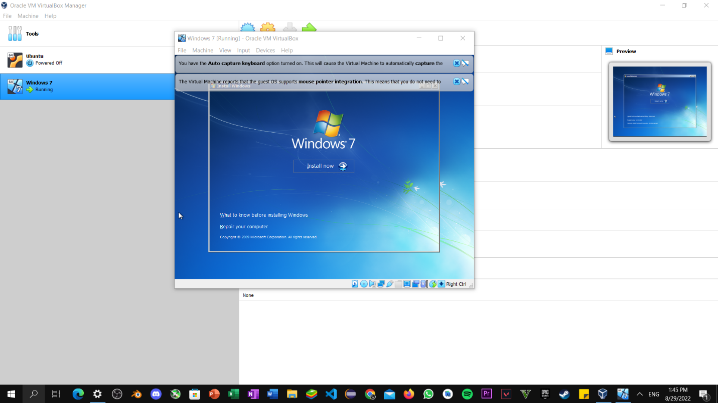

Step9: Now check I accept all terms and condition and click on next button.

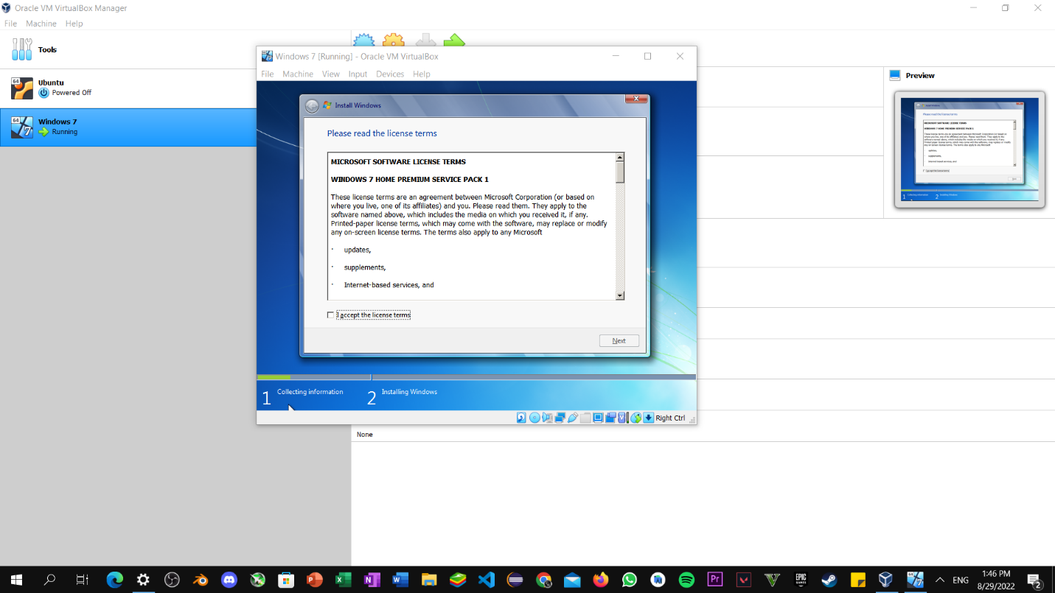

Step10: Wait till the Installation part Being completed.

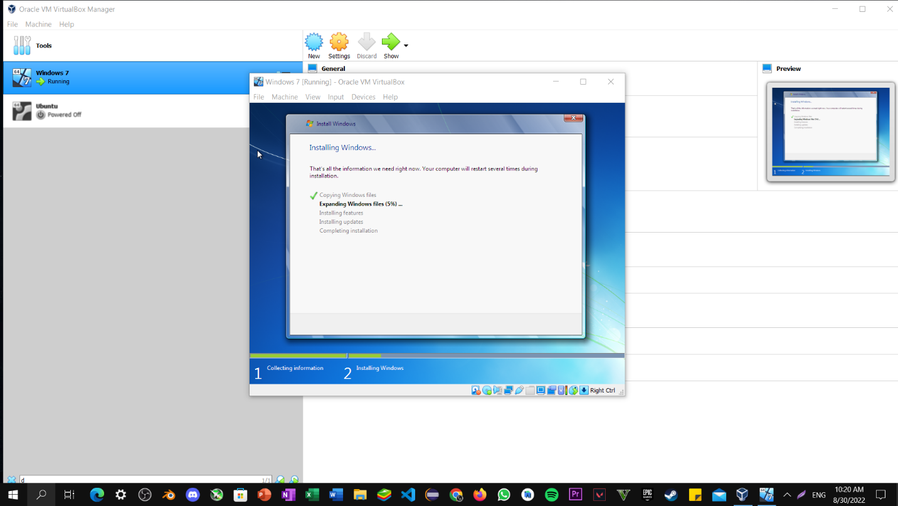

Step11: Wait till installation, completed and then reboot virtual machine.

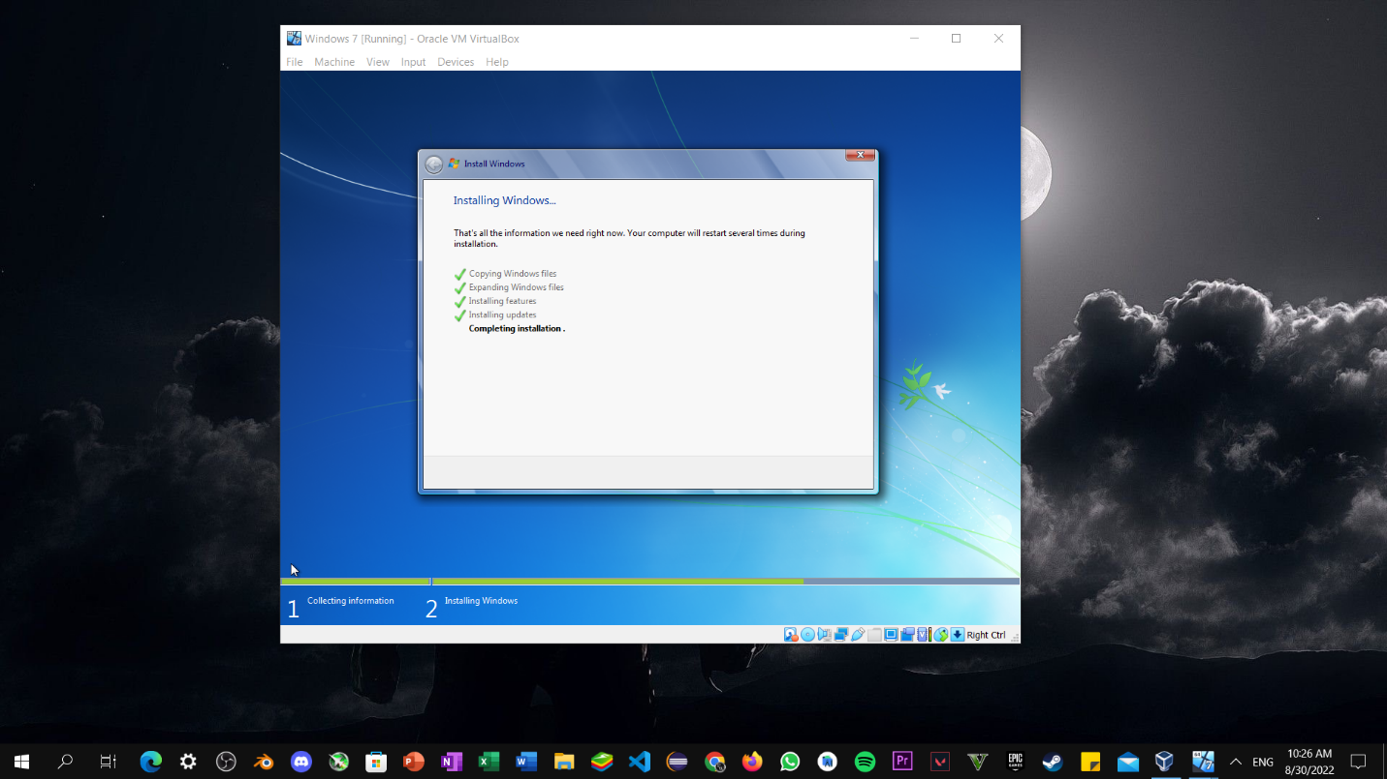

Step12: Windows 7 Workspace

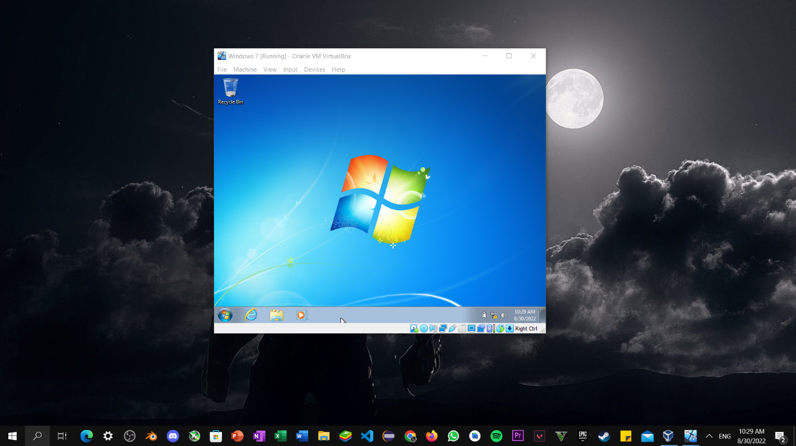

CentOS Installation

Step1: Press enter on Install CentOS.

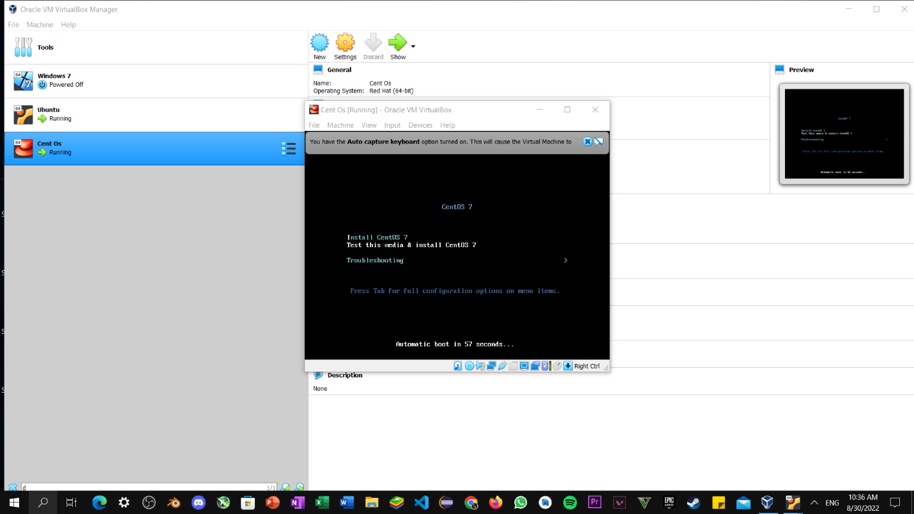

Step2: Now wait for Installation.

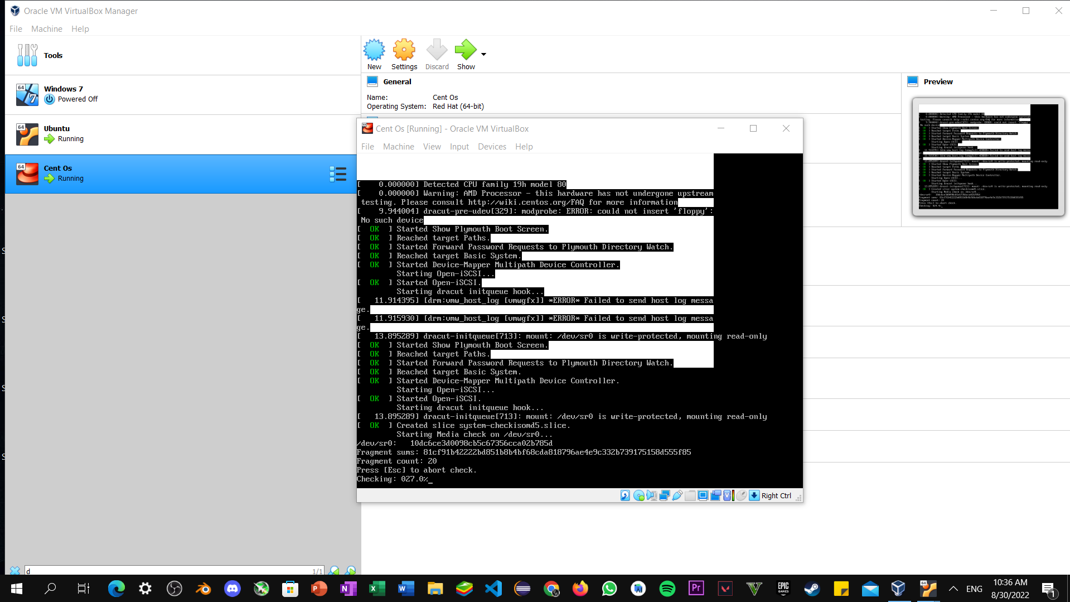

Step3: Now, Select Language and click on continue button for proceed further.

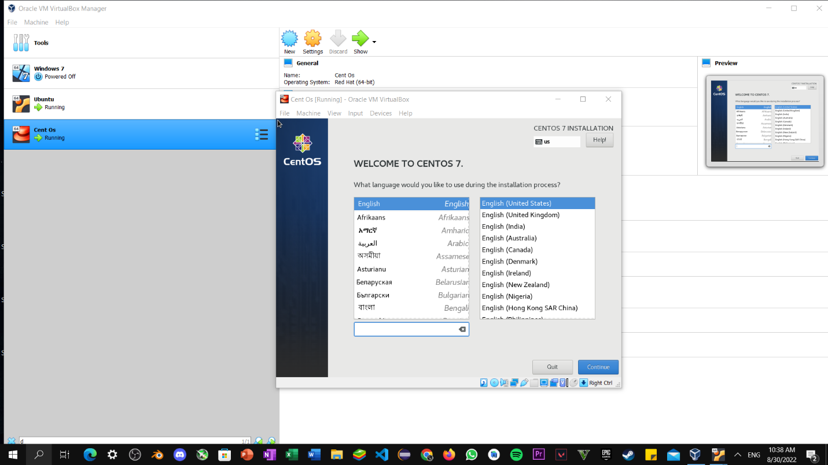

Step4: Setup User Password and setting and click on install button.

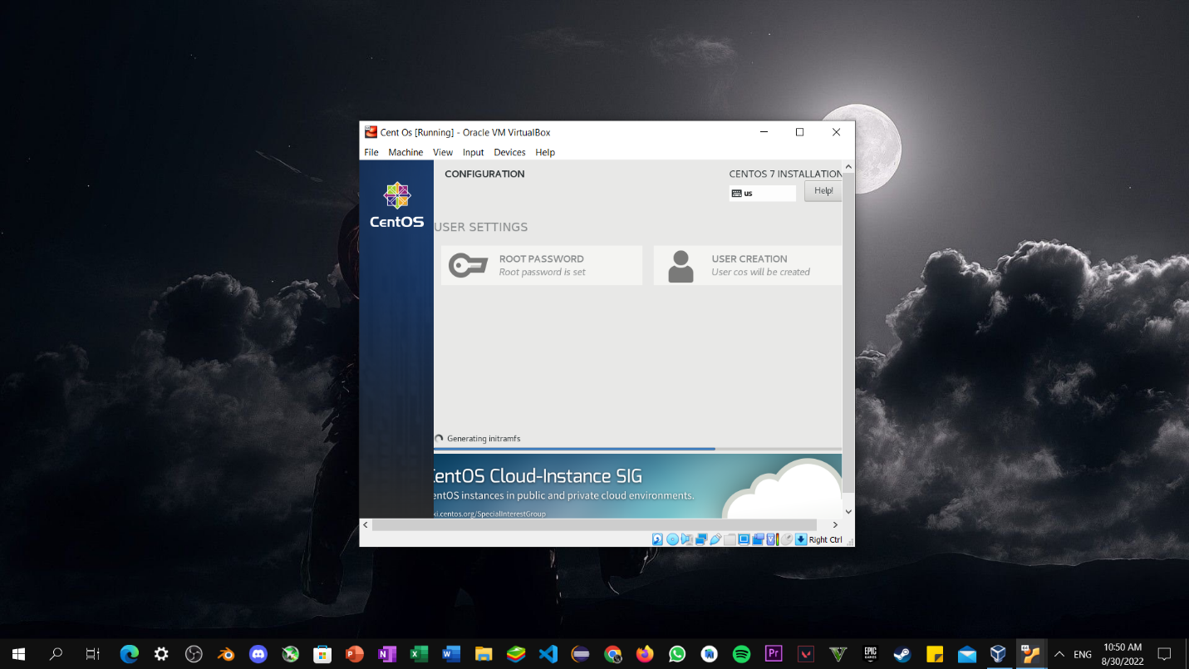

Step5: Setup User Password and setting and click on install button.

